# **I. Title:** Consolidation and Change: Exploring the Impact of Anger and Attitude Dynamics on Inequality Belief Systems

# II. Abstract and keywords

Inequality is a critical global issue, particularly in the United States, where economic disparities are among the most pronounced. Social justice research traditionally studies attitudes towards inequality—perceptions, beliefs, and judgments—using latent variable approaches. Recent scholarship adopts a network perspective, showing that these attitudes are interconnected within inequality belief systems. However, scholars often compare belief systems using split-sample approaches without examining how emotions, such as anger, shape these systems. Moreover, they rarely test Converse’s seminal idea that changes in central attitudes can lead to broader shifts in belief systems. Addressing these gaps, we applied a tripartite analytical strategy using U.S. data from the 2019 ISSP Social Inequality module. First, we used a mixed graphical model to demonstrate that inequality belief systems form cohesive small-world networks, with perception of large income inequality and belief in public redistribution as central nodes. Second, a moderated network model revealed that anger towards inequality moderates nearly one-third of network edges, consolidating the belief system by polarizing associations. Third, Ising model simulations showed that changes to central attitudes produce broader shifts across the belief system. This study advances belief system research by introducing innovative methods for comparing structures and testing dynamics of attitude change. It also contributes to social justice research by integrating emotional dynamics and highlighting anger’s role in structuring inequality belief systems.

Keywords: Belief systems; Attitudes towards inequality; Social justice research; Attitude change; Anger.

# III. Main text

## 1. Introduction

Inequality is one of the most pressing challenges in contemporary societies, particularly in the United States, where economic disparities are among the highest in Western nations (Atkinson et al., 2011; Neckerman & Torche, 2007). Over recent decades, rising disparities have created significant gaps in living conditions (Wilkinson & Pickett, 2009), with the richest 10% controlling about 70% of wealth while the bottom half owns less than 2% (Chancel et al., 2022). These issues are exacerbated by strong socioeconomic segregation (Mijs & Roe, 2021) and limited social mobility (Hout, 2018; OECD, 2018). Despite these economic gaps, public concern about inequality has not risen proportionately (Kenworthy & McCall, 2007; Lierse et al., 2022), with individuals often misunderstanding or underestimating its extent (Chambers et al., 2014; Trump, 2023). The U.S. is an especially relevant context for studying attitudes towards inequality due to its deep disparities and a long tradition of research in this field (e.g., Kluegel & Smith, 1981; McCall, 2013). Prior studies highlight the U.S. public’s strong belief in meritocracy (Mijs, 2018) and relatively low support for redistribution (Alesina et al., 2001; Hoy & Mager, 2021).

Research on distributive justice has traditionally relied on the latent variable approach, which consolidates multiple perceptions, beliefs, and judgments into mean indexes. This approach often leads to an unsystematic examination of these attitudes, with most studies focusing on only one aspect (Janmaat, 2013).  Moreover, research has primarily focused on the levels of these attitudes (i.e., their public endorsement), often overlooking the cognitive structure in which they are embedded. This is crucial because attitudes do not exist in isolation but are interconnected within a broader belief system (Converse, 2006). Recent interdisciplinary research has provided innovative methodologies for analyzing the multifaceted components of attitudes towards inequality and understanding their structural organization. A new scholarship in distributive justice indicates that these attitudes form inequality belief systems, which are mental structures composed of nodes representing survey variables and ties representing their statistical associations in the data (Bertero et al., 2024; Franetovic & Bertero, 2023). Further, research has revealed that the structure of attitudes towards inequality varies across different social strata (DiMaggio & Goldberg, 2018; Franetovic & Bertero, 2023; Hunzaker & Valentino, 2019). These inquiries complement latent variable approaches by shifting the focus from individuals’ normative views on inequality to understanding how these stances are organized within broader mental structures (Brandt & Sleegers, 2021; Dalege et al., 2016).

The network approach to studying attitudes towards inequality has two major limitations. First, researchers often split samples into groups to examine belief systems, either by grouping individuals with similar attitudinal structures (DiMaggio & Goldberg, 2018; Hunzaker & Valentino, 2019; Kesberg et al., 2024) or by comparing the belief systems of individuals with different socio-demographic characteristics (Franetovic & Bertero, 2023; Schlicht-Schmälzle et al., 2018). While useful, this reduces statistical power and assumes belief systems differ only between groups, ignoring variations within them. Second, studies rarely examine attitude change, overlooking Converse’s (2006) key proposition that shifts in one belief can realign others. For instance, heightened awareness of income inequality might lead to stronger support for redistributive policies, yet this dynamic remains largely unexplored (Brandt & Sleegers, 2021).

We craft a tripartite analytical strategy to address the limitations in the study of inequality belief systems. First, we *model* U.S. attitudes towards inequality as a belief system using ISSP data, creating a weighted and signed network that captures the relationships between perceptions, beliefs, and judgments of inequality. Second, we *estimate* how this structure varies across the population, focusing on the role of anger towards inequality. By applying a Moderated Network Model, we show that angry individuals possess more interconnected and polarized belief system structures. Finally, we *simulate* attitude change to investigate whether altering central nodes leads to broader adjustments within the belief system.

Our contribution is structured as follows. Section 2 introduces the concept of attitudes towards inequality and reviews network approaches to address their structure. Section 3 details the ISSP data and methods used. Section 4 confirms that U.S. attitudes form a small-world inequality belief system centered on public redistribution and income inequality, with significant variations based on anger levels. We also show that changes in central beliefs drive substantial system-wide adaptations. The study concludes with a discussion of its methodological and theoretical contributions and directions for future research.

## 2. Theory

### 2.1 Attitudes towards inequality

Attitudes are “general evaluations that people hold regarding a particular entity, such as an object, an issue, or a person” (Lavrakas & J., 2008; p.39). They are evaluative, general, and enduring, making them distinct from moods or rapid impressions. Studied for their strong predictive power of social and political behaviors (Hatemi & McDermott, 2016), attitudes are typically measured through surveys using Multi-Item Likert scales, where responses are summed or weighted to represent an individual’s stance.

Particularly, attitudes towards inequality represent a multifaceted concept, including perceptions, beliefs, and judgments about the distribution of resources within a society (Janmaat, 2013). Perceptions refer to subjective estimations about the scope of inequality (Castillo et al., 2022; Heiserman & Simpson, 2021). Instead, beliefs correspond to normative ideas about how inequality ought to be. Indeed, this dimension is frequently measured with indicators similar to the ones of perceptions, but situating individuals in an ideal scenario (Osberg & Smeeding, 2006). Finally, judgments represent evaluations of existing inequality and refer to how good, desirable, fair, or just individuals rate the current distribution (Kelley & Evans, 1993).

Inequalities stem from various social, economic, and political arrangements (McCall & Percheski, 2010), making several interconnected fields crucial for understanding attitudes towards inequality (McCarty & Pontusson, 2011). The way welfare states collect and redistribute resources through social programs and transfers significantly shapes societal inequality (Esping-Andersen & Myles, 2011; Korpi & Palme, 1998; Volscho & Kelly, 2012). Additionally, evaluations of taxes, redistribution, and wages are closely tied to perceptions, beliefs, and judgments about inequality (Bartels, 2005; Berens & Gelepithis, 2019; Bussolo et al., 2021; Choi, 2021; Fatke, 2018; García‐Sánchez et al., 2020; Iacono & Ranaldi, 2021; Trump, 2023). Understanding inequality thus requires delving into subjective perceptions of these interconnected issues. Indeed, the literature highlights various connections between perceptions, beliefs, and judgments about inequality, taxes, redistribution, and wages. For instance, individual perceptions of inequality influence normative ideas about how society should be structured (Pedersen & Mutz, 2019), support for public redistribution (Gimpelson & Treisman, 2018; Kuhn, 2011; Kuziemko et al., 2015; Trump, 2023), and attitudes towards progressive taxation (García‐Sánchez et al., 2020).

Anger plays a crucial role in shaping attitudes towards inequality, yet remains understudied in social justice research. U.S. citizens with lower social status report higher levels of anger, often driven by frustration, inferiority, and perceived injustice (Park et al., 2013). Anger not only reflects personal grievances but also has broader societal implications. Comparative studies reveal that angry individuals are less likely to support conservative economic parties and more likely to back progressive ones (Gonthier, 2023). It strengthens the link between perceptions of inequality and the willingness to engage in political action (Leach et al., 2006) and mediates the relationship between perceived inequalities and psychological well-being (Vezzoli et al., 2023). These findings suggest that anger amplifies connections between distributive evaluations, moderating the structure of inequality belief systems and underscoring its importance in understanding attitudes.

Beyond cross-sectional studies, researchers have also examined how attitudes towards inequality evolve, yielding mixed results. Cruces and colleagues (2013), using an experimental survey in Argentina, demonstrated the significant role of perceptions in shaping distributional beliefs. Their findings revealed that individuals who overestimated their relative social position became more supportive of redistribution when informed of their actual placement in the social hierarchy. Similarly, Campos-Vazquez et al. (2022) conducted an experimental study in Mexico, providing participants with objective information about income inequality and social mobility. Unlike the Argentine study, their results showed that altering perceptions of inequality did not lead to changes in participants’ normative beliefs about income distribution, social mobility, or tax rates.

### 2.2 Inequality Belief Systems

In response to the unsystematic nature of previous research, a new strand of the literature has emerged, examining the structure of attitudes towards inequality (Franetovic & Bertero, 2023). This approach focuses on how perceptions, beliefs, and judgments about economic disparities, redistribution, taxation, and wage allocation interact to form an interconnected inequality belief system (Bertero et al., 2024). This approach, rooted in the work of Converse (2006), complements the traditional latent variable model commonly used in attitude research. Latent models conceptualize attitudes as unobservable constructs that are reflected in observable evaluations of attitude objects (Eagly & Chaiken, 1993; Rosenberg, 1960). They rely on assumptions of local independence—where observed indicators are thought not to influence each other once the latent attitude is accounted for—and exchangeability—where adding more items only enhances reliability without contributing new information (Bagozzi, 1981; K. A. Bollen, 1989; K. Bollen & Lennox, 1991).

The belief system literature incorporates cognitive consistency and accuracy as core mechanisms, suggesting that attitudes develop incrementally through associations with related beliefs (Dalege et al., 2016). For instance, individuals might first perceive high levels of income inequality and judge them as fair or unfair (Time 1). Over time, they could associate this judgment with beliefs about the causes of inequality, such as the gender pay gap (Time 2), and later expand these associations to include political inaction (Time 3) or the role of race and religion in personal success (Times 4 and 5). In this process, individuals aim to minimize cognitive inconsistency by forming coherent stances on subjective inequality (Dalege, Borsboom, Harreveld, Waldorp, et al., 2017). However, belief systems must also balance consistency with accuracy, allowing for misaligned evaluations. For example, individuals might believe inequality is high due to the gender pay gap but see race and religion as irrelevant to the inequality equation.

This dual process generates two patterns. First, the expansion of belief systems involves nodes unequally, as some components—like those with strong initial associations—are more likely to connect with newer perceptions, beliefs, and judgments, resembling patterns of preferential attachment (Barabási & Albert, 1999; Dalege et al., 2016, 2018). Consequently, beliefs differ in centrality within the network. Second, aligned and misaligned evaluations are organized to coexist without psychological distress. To achieve this, belief systems exhibit high clustering, grouping coherent evaluations within the same substructures while placing mismatched ones in distinct areas of the network (Dalege et al., 2019).

Researchers in this field have primarily used two methodologies. On the one hand, scholars have used Correlational Class Analysis (CCA; Boutyline, 2017) or Relational Class Analysis (RCA; Goldberg, 2011). These techniques group individuals based on similar correlational patterns among their attitudes, mapping belief systems as networks of associations without assuming shared normative positions. For example, Kesberg et al. (2024) applied CCA to examine the validity of system justification theory (Jost & Van der Toorn, 2012), finding that social status negatively correlates with support for the status quo only within specific population segments, not universally. Using RCA, DiMaggio and Goldberg (2018) identified three distinct ways the U.S. public organizes attitudes towards the market: an “economistic” class favoring markets as beneficial, a “hostile worlds” class supporting markets but restricting morally contentious transactions (e.g., organ sales), and a “progressive” class endorsing markets with regulatory interventions to address market failures and protect public welfare.

A second class of network methods, introduced by Boutyline and Vaisey (2017) and refined through advancements in network psychometrics (Borsboom et al., 2021) and political psychology (Brandt, 2022; Brandt et al., 2019), represents attitudes as nodes within weighted and signed networks, with edges indicating partial correlations between survey items. Franetovic and Bertero (2023) applied this approach to study inequality attitudes in Chile, revealing an integrated belief system with a small-world structure. They also found that lower social groups exhibit higher connectivity, a feature linked to attitude strength (Dalege et al., 2019). Combining CCA with partial correlation networks, Bertero et al. (2024) identified two distinct types of belief systems in the U.S. and the Netherlands, showing that the organization of these systems significantly predicts support for public redistribution.

### 2.3 Research hypotheses

This section outlines our research hypotheses. Attitudes are conceptualized as networks of evaluations, where some nodes form more connections, bridging areas of the network and enhancing connectivity. These networks are typically clustered to balance accuracy and consistency, resembling small-world structures (Watts & Strogatz, 1998). Small-world properties have been validated across various contexts, including attitudes towards political candidates (Dalege, Borsboom, Harreveld, & Maas, 2017; Dalege, Borsboom, Harreveld, Waldorp, et al., 2017; Dalege et al., 2016) post-national citizenship identities (Schlicht-Schmälzle et al., 2018), job satisfaction (Carter et al., 2020), bio-based plastic (Zwicker et al., 2020), political values (Turner-Zwinkels et al., 2020), and inequality (Franetovic & Bertero, 2023). Based on this, we hypothesize:

*H1: The inequality belief system will exhibit a small-world structure.*

Beliefs differ in importance. For networks estimated with cross-sectional data, centrality reflects how strongly a node interacts with others, without indicating directionality—it may predict, be predicted by, or both (Bringmann et al., 2019). In social justice research, the perception of large income inequality is often treated as an independent variable, influencing attitudes like support for redistribution (Gimpelson & Treisman, 2018; Trump, 2023), ideal distributions (Pedersen & Mutz, 2019), and progressive taxation (García‐Sánchez et al., 2020). Conversely, the belief in public redistribution is typically a dependent variable shaped by factors such as social class (Langsæther & Evans, 2020), subjective social status (Choi, 2021), beliefs about intergenerational mobility (Alesina et al., 2018), social comparison processes (García‐Castro et al., 2022), trust in the political system (Franetovic & Castillo, 2022). These two attitudes are positively correlated (Gimpelson & Treisman, 2018; Kuhn, 2011; Kuziemko et al., 2015; Trump, 2023) and play a pivotal role in distributive justice research. Notably, Franetovic & Bertero (2023) found them to be the most central nodes in Chile’s inequality belief system. Therefore:

*H2: Perception of large income inequality and belief in public redistribution will be the most central nodes in the inequality belief system.*

The first two hypotheses examine the attitudinal structure at the population level, yet full-sample data may obscure structural heterogeneities (DiMaggio et al., 2018). Social positions influence relational structures, with lower income, education, and social class linked to more densely connected inequality belief systems (Franetovic & Bertero, 2023). Anger might play a central role in shaping these systems, reinforcing the connections between distributive attitudes. Indeed, anger was observed to promote greater consistency between implicit and explicit attitudes by fostering a sense of certainty (Huntsinger, 2013). The neural basis of anger’s influence further underscores its critical role: anger enhances certainty through activation of brain regions associated with confidence (Luttrell et al., 2016). Furthermore, anger stabilizes attitudes by increasing emotional involvement, which reduces susceptibility to change over time (Rocklage & Luttrell, 2021). As an active emotion, anger increases attitude-behavior consistency by energizing individuals to act in line with their beliefs (Seitz et al., 2007). Moreover, anger mobilizes individuals by sharpening selective cognitive processing, which polarizes belief systems and reinforces attitude interconnections (Pomerantz et al., 1995). Together, these findings emphasize anger can be expected to relate with attitude strength. Therefore:

*H3: Anger towards inequality will consolidate the structure of the inequality belief system, such that negative relationships will become more negative and positive relationships will become more positive.*

Network approaches to belief systems provide a formalized theory of attitude change. Nodes vary in centrality, and changes in central nodes are expected to produce larger shifts in the network compared to peripheral ones (Brandt et al., 2019; Converse, 2006). This has been confirmed through simulations, where changes in central nodes create downstream effects, causing neighboring nodes to adjust their states (Dalege, Borsboom, Harreveld, & Maas, 2017; Dalege, Borsboom, Harreveld, Waldorp, et al., 2017). Similar effects, albeit weaker, have been observed in longitudinal studies of job satisfaction (Carter et al., 2020), COVID-19-related attitudes (Chambon et al., 2022), and political beliefs (Turner-Zwinkels & Brandt, 2022). Given the absence of panel data on subjective inequality—and cumulating with H2—this study simulates manipulations targeting each node to test whether:

*H4: Simulated manipulation attempts targeting the perception of large income inequality and the belief in public redistribution will produce downstream effects in the inequality belief system.*

## 3. Methods

### 3.1 Data and variables

We use the ISSP 2019—Social Inequality V module (ISSP Research Group, 2022), which includes several indicators of subjective inequality. We analyze U.S. data, collected with a multistage probabilistic design and Computer Assisted Web Interface methodology. The sample is representative of the population aged 18 years or older. The original dataset includes 1,852 individuals. Table 1 shows the 22 selected variables and their corresponding ISSP questions. High scores indicate high perceptions of inequalities, egalitarian beliefs, and judgments of unfairness about existing levels of social disparities. All variables are measured on a 1 to 5 scale, with the exceptions of *Judgment of unfair distribution[1]* (1-4) and *Anger towards inequality* (0-10). Listwise deletion reduces the sample to 1,188 individuals[2].

To cumulate with past research, the article includes twelve perceptions, seven beliefs, and three judgments about inequality in the U.S. (see Franetovic & Bertero, 2023). Respondents were asked to report their *Perception of large income inequality* and their *Perception of tax regressivity*. The analyses include ten explanations of inequality, also known as inequality beliefs (Mijs, 2018), which are items asking respondents to indicate how important they perceive a set of structural and individual factors to be for getting ahead in life (*Importance of wealthy family, parental education, own education, hard work, knowing the right people, political connections, giving bribes, personal race, religion,* and *sex*). Belief items ask respondents to express normative judgments on how they would desire society to be organized. The questionnaire included the *Belief in progressive taxation*, *public redistribution,* and *market redistribution*. Moreover, one survey battery taps into beliefs on just pay criteria, asking respondents to indicate whether they would agree on wages to be regulated based on the responsibility associated with the job, or on workers’ training levels, needs, and merits (*Pay criteria responsibility training, need, merit*). Finally, respondents judged the fairness of the existing income distribution in the U.S. (*Judgment of unfair distribution*), the extent to which politicians are distrusted (*Judgment of political distrust in redistribution*), and unsuccessful (*Judgment of failure of public redistribution*) in addressing and fighting inequality. Finally, the 2019 ISSP Social Inequality module measures, for the first time, individuals’ anger towards inequality. This item is addressed with the following survey question: “Some people feel angry about differences in wealth between the rich and the poor, while others do not. How do you feel when you think about differences in wealth between the rich and the poor in the U.S.?”.

[TABLE 1 ABOUT HERE]

### 3.2 Network estimation

Network estimation follows several steps (Borsboom et al., 2021). Variables are first selected through a literature review to ensure construct validity. Survey data is then analyzed using Graphical Models, which encode conditional dependencies as network edges and independencies as their absence (Lauritzen, 1996). The resulting undirected network represents the aggregate structure of the U.S. inequality belief system. Structural properties are analyzed, and parameter stability is tested using bootstrapping (Efron, 1979).

To address H1 and H2, a Mixed Graphical Model (mgm) is estimated (Haslbeck & Waldorp, 2020). This model accommodates variables measured at different scales and estimates parameters through a loop of node-wise regularized linear regressions. At the beginning of the analysis, variables are mean-centered and rescaled. Then, each variable is iteratively regressed on every other, while controlling for the remaining nodes. To avoid multicollinearity issues and to model specificity, mgm uses L1-penalized regression (LASSO) (Tibshirani, 1996). LASSO regularization induces sparsity in the network matrix, as it forces smaller coefficients to become exactly zero, effectively performing variable selection. The LASSO tuning parameter is searched with a model selection approach and is found by minimizing the Extended Bayesian Information Criterion, an extension of the BIC (Schwarz, 1978) that penalizes with additional intensity nonzero parameters . This strategy is extensively validated (Epskamp & Fried, 2018; Foygel & Drton, 2010; Haslbeck & Waldorp, 2020) and allows the quantification of node predictability. Since all variables are modeled as continuous, R2 values are reported, and edges are interpretable as regularized linear regression coefficients (Burger et al., 2022).

H1 and H2 are tested on the mgm network[3]. The small-worldness of the network, assessed using Telesford et al.’s (2011) test, compares clustering and connectivity with a lattice network of the same size. Clustering measures the extent to which nodes form cliques (Watts & Strogatz, 1998), and connectivity is evaluated via the Average Shortest Path Length[4] (ASPL). Networks are small-world if their connectivity matches or exceeds a random network and their clustering is higher, producing values between −0.5 and 0.5. The centrality of network nodes is calculated with the Strength metric, which sums the absolute values of the edge weights of the relationships in which a node is involved (Opsahl et al., 2010). Strength captures direct, pairwise associations between attitudes, providing a robust measure of each node’s importance within the inequality belief system[5].

H3 investigates whether the network structure estimated on the full sample hides structural heterogeneities that are produced by different levels of anger towards inequality. A common approach for testing research questions involving group differences is to split the sample by the levels of a third variable, estimate two network models, and compare them with a permutation-based Network Comparison Test (Borkulo et al., 2022). The split-sample strategy is commonly used by scholars employing a network approach to examine the structure of socio-political attitudes. Yet, these procedures are impeded by two shortcomings. First, data-split approaches reduce sample size, and thus statistical leverage; second, these strategies can only model a step moderation process, where the slope of a relationship can differ between two groups, but not within them. The Moderated Network Model (MNM) mitigates both problems (Haslbeck et al., 2021). Its edges are estimated with the same strategy outlined above, relying on a set of regularized linear regressions whose tuning parameter is obtained by minimizing the EBIC. However, in each of these regressions, the MNM adds a moderation effect of a selected variable. Therefore, MNM produces two parameter matrices, one for the pairwise and one for the three-way interactions. To address H3, this article fits an MNM in which anger towards inequality is specified as a moderator. H3 is confirmed if anger meaningfully moderates network edges.

H4 is tested with a network simulation that requires variables’ dichotomization[6]. Edges of this model represent associations between binary nodes and are estimated with logistic—rather than linear—regularized regressions. Hence, the mgm reduces to an Ising model (Ising, 1925), whose edges are interpretable as logistic regression coefficients (Borkulo et al., 2015). The Ising model can estimate two additional classes of parameters that are discussed in Section 3.3.

We evaluate the robustness of edge weights (Figures 2 and 4, Supplement) and of the moderation effects of anger (Table 2, Supplemental Material) with non-parametric bootstrapping (Epskamp et al., 2018), generating 10,000 resamples on which we re-estimate networks, to estimate 95% confidence intervals. Strength centrality stability is tested with case-dropping bootstraps, yielding the Correlation Stability (CS) coefficient, which should exceed 0.25, preferably 0.50. Bootstrapped difference tests compare edges or Strength scores, with non-overlapping intervals indicating significant differences.

Last, we adopt community detection techniques to investigate how nodes of the inequality belief system cluster together. To cumulate with the partial-correlation-based Exploratory Graph Analysis (EGA) technique, we adopt the Walktrap community detection algorithm (Golino et al., 2020, p. 202; Golino et al., 2017)[7]. In the remainder of the Methods section, we detail our simulation of attitude change.

### 3.3 Network simulation

H4 is tested through a simulation of network dynamics using Ising’s model (Dalege, Borsboom, Harreveld, & Maas, 2017; Ising, 1925), where nodes represent endorsement or rejection of survey items (-1 or +1). The temperature parameter, governing system entropy, remains constant across simulations due to its correlation with attitude strength (Dalege et al., 2018). Two additional parameters, described by the Hamiltonian function, estimate the energy expenditure of the network configuration:

Each network node (Xᵢ to Xⱼ) has a threshold (𝛕ᵢ to 𝛕ⱼ) ranging from -1 to +1, indicating its likelihood of being endorsed (+1) or not (-1). The ω parameter models the strength of nodes interactions, with positive values for positive associations and vice versa. Configurations of the belief system where nodes with positive thresholds are connected with positive edges minimize energy expenditure, aligning with the Ising model’s principle that attitudes favor low-energy configurations.

The simulation models persuasion attempts targeting one node at a time and has already been applied to socio-political attitudes (Dalege, Borsboom, Harreveld, & Maas, 2017; Schlicht-Schmälzle et al., 2018). Manipulations increase node thresholds (𝛕), with the dependent variable being the sum score of attitudes towards inequality[8] before and after each manipulation. H4 is supported if changes in the *perception of large income inequality* and *belief in public redistribution* cause downstream effects, where a node’s state change influences others. The simulation creates 23 samples of 3,000 individuals answering 22 survey items. In the baseline, all nodes have a threshold of -0.1; in all other samples, one node is set to +1[9]. Networks are estimated after each iteration, and sum scores are compared to assess structural changes.

## 4. Results

### 4.1 Modelling the inequality belief systems

Table 1 in the Supplemental Material shows descriptives of the 22 attitudes. U.S. citizens widely perceive economic disparities, support egalitarian distribution, and view current inequalities as unfair. They see income inequality as significant, the tax system as regressive, and success as mostly tied to hard work and education. Respondents favor progressive taxation, expect action from corporations and public institutions to reduce income differences, and prioritize merit in wage allocation. They also view political actors as disinterested and ineffective in addressing inequalities.

**[FIGURE 1 ABOUT HERE]**

Figure 1 illustrates the U.S. inequality belief system, with nodes representing the 22 perceptions, beliefs, and judgments, colored according to community detection results. The network is visualized using a force-directed layout (Fruchterman & Reingold, 1991), with edges indicating positive (blue) or negative (red) associations between items. The attitudes form a single, cohesive belief system, showing that U.S. citizens organize their views on inequality, taxation, redistribution, and wages into one mental framework.

The strongest positive associations in the model link explanations based on race and sex, political connections and knowing the right people, and perceptions of income inequality with support for public redistribution. The strongest negative associations in the network are those between explanations considering the importance of hard work and giving bribes, inequality beliefs pointing at the importance of wealthy families and hard work, and between the belief in public redistribution and responsibility as pay criteria.

Network edges reveal two main patterns. First, most associations are positive, reflecting the coherent organization of U.S. citizens’ high perceptions, egalitarian beliefs, and severe judgments about inequality. Second, the strongest connections occur between variables within the same conceptual domain. For example, pay criteria such as merit, responsibility, and training are strongly linked, as are the ten explanations of inequality, clustered at the bottom of Figure 1.

Structuralist explanations like religion, race, and sex are more likely to interact with each other than with individualist factors like hard work or education. Moreover, we also retrieve strong associations between different types of attitudes towards inequality, such as those between the perception of large income inequality and the belief in public redistribution, or between the perception of tax regressivity and the belief in progressive taxation. Moreover, believing in need as a pay criterion is largely unrelated to endorsing merit or responsibility. Therefore, not all semantically related attitudes strongly correlate.

These associations create four distinct network communities, each representing different domains of attitudes towards inequality. The structuralist community (yellow) focuses on societal divisions that contribute to inequality, such as race, religion, and sex. The individualist community (green) centers on factors tied to individual agency, including hard work, education, and responsibility, merit, and training as pay criteria. The mixed community (blue) encompasses meso-level explanations rooted in social contexts, such as the importance of knowing the right people, having political connections, or coming from a wealthy family. Lastly, the red community includes all judgments, perceptions, and beliefs related to both public and private redistribution.

Node predictability measures how much of a variable’s variance is explained by the network model. Pay criteria show the lowest predictability, suggesting they are less integrated into the network and influenced by factors external to the model. In contrast, the perception of large income inequality and the belief in public redistribution have the highest predictability, indicating that their levels are primarily determined by other variables included in the network model. This supports the validity of item selection, as key variables in inequality research are well-modeled by the inequality belief system.

According to belief system theory, this system is expected to exhibit a small-world structure (H1), balancing individuals’ needs for accuracy and consistency. Structurally, the network shows low density, with only 30.6% of possible edges present. Compared to a random network, it has a higher average shortest path length (ASPL) and lower clustering coefficient, resulting in a small-world score of 0.228, confirming H1.

We also hypothesize that the belief in public redistribution and the perception of large income inequality are the most central nodes (H2). Figure 2 shows their high Strength centrality scores, indicating strong and frequent connections with other nodes. These variables consistently rank as the most central in both the full-scale and bootstrapped networks, with the belief in public redistribution slightly more central overall. Notably, centrality stability is high, with results remaining reliable even when 75% of the sample is dropped. Peripheral nodes include the four pay criteria and the belief in market redistribution, showing that high endorsement does not guarantee centrality. For example, while the support for market redistribution has a higher average endorsement than public redistribution, the latter is far more central, underscoring its pivotal role in the inequality belief system.

[FIGURE 2 ABOUT HERE]

### 4.2 Exploring the impact of anger on the inequality belief system

Figure 3 confirms our hypothesis (H3) that anger towards inequality moderates the belief system’s structure. Each panel shows networks estimated at different anger levels, with anger depicted as a separate white node. More than 25 edges are strongly influenced by anger, as detailed in Table 2 of the Supplemental Material, with effects consistently found in over 83% of bootstrapped samples, ensuring robust results.

[FIGURE 3 ABOUT HERE]

The strongest moderation effect involves the relationship between the judgment on the failure of public redistribution and the belief in public redistribution. The magnitude of this moderation effect equals 0.064. Indeed, when anger scores zero, a unit increase in the belief in public redistribution corresponds to a 0.025-unit increase in the judgment of its failure. As anger rises, this relationship strengthens. For example, when anger scores 3 (top-right panel of Figure 3), the relationship increases to 0.217, reaching 0.473 and 0.665 in the bottom panels. This moderation shows that anger towards inequality amplifies the link between these variables. Therefore, Figure 3 underscores that the associations between distributive attitudes are generally stronger for individuals who are angry towards inequality.

Anger strongly moderates relationships between explanations of inequality. As anger increases, distinctions between individualist, structuralist, and mixed explanations become more pronounced. For example, at low anger, perceiving a wealthy family as important weakly predicts considering sex as significant, but this link strengthens significantly at high anger. Similarly, the connection between perceiving the importance of coming from a wealthy family and political connections grows for angry individuals. In contrast, anger sharpens divides between structuralist and individualist factors. For example, when anger is low, parental education and race are unconnected, but at high anger, they are strongly and negatively connected. Similarly, the weak negative association between personal education and giving bribes becomes strongly opposed.

Anger also alters the role of specific variables, such as the importance of education and the belief in market redistribution. At low anger, education is weakly associated with the belief in market redistribution, but this link becomes much stronger at high anger. As a result, the belief in market redistribution, typically peripheral in the network, becomes more central when anger is high, interacting more strongly with other perceptions and beliefs.

At low levels of anger (top panels of Figure 3), the inequality belief system mirrors the full sample network (Figure 1), with four distinct network communities. However, as anger increases, the network consolidates into fewer communities, reflecting stronger interactions among distributive attitudes. When individuals experience higher anger (bottom panels of Figure 3), their belief system is structured into three communities, with explanations of inequality merging into a single group. This suggests that heightened anger drives U.S. citizens to see individual, structural, and mixed factors as increasingly interconnected in shaping social inequalities.

Anger intensifies most of the associations within the network, making attitudes towards inequality more contentious. Indeed, at low anger, the networks show weaker connections and fewer negative associations; for example, mean absolute edge weights are 0.061 and 0.068, with 46 and 59 negative edges when anger scores 0 and 3. At higher anger (scores 7 and 10), mean edge weights increase to 0.101 and 0.127, and negative edges rise to 62 and 63. This intensification means positive associations become stronger, while null or weakly negative relationships turn strongly negative, leading to a more polarized and tightly connected belief system.

### 4.3 Simulating attitude change

To test whether changes in central nodes trigger larger adjustments than peripheral ones, variables were dichotomized, and an Ising simulation was conducted. Table 1 in the Supplemental Material provides descriptives, and Figure 4 shows the resulting network (top) and node strength centrality (bottom)

[FIGURE 4 ABOUT HERE]

In Figure 4, edges represent regularized logistic regression coefficients, with the layout replicating Figure 1 for comparability. The Ising network has similar density (0.32) and retains the strongest associations from the full-scale model, such as links between race and sex, tax regressivity and progressive taxation, and large income inequality and public redistribution. Strength scores and communities remain consistent, with the perception of large income inequality, the importance of race, and the belief in public redistribution as the most central nodes, while pay criteria and the belief in market redistribution are the most peripheral.

Figure 1 in the Supplemental Material compares standardized centrality scores from the two models, showing minimal variation in rankings. The main exception is the belief in public redistribution, which ranks first in the mgm network but third in the Ising model. In both models, the perception of large income inequality, the importance of race, the belief in public redistribution, and the importance of wealthy families consistently score highest in centrality, with overlapping bootstrapped confidence intervals for most differences. However, the perception of large income inequality and the belief in public redistribution remain more central than all other nodes. Furthermore, the CS coefficient remains high (0.75), and the Ising network is confirmed to have a small-world structure (0.223).

[FIGURE 5 ABOUT HERE]

H4 predicts that changes in central nodes will produce downstream effects, triggering broader adjustments in the inequality belief system. To test this, we simulate manipulations targeting one node at a time by increasing its threshold—a parameter modeling the predisposition to endorse each attitude—from -0.1 to +1, while keeping the thresholds of other nodes fixed at -0.1. According to the Hamiltonian function, increasing a node’s threshold does not guarantee a state change (i.e., from “not endorsed” to “endorsed”), as nodes are influenced not only by their predisposition but also by their connections to other nodes (ω parameter).

Figure 5 presents the results of the simulated manipulations through a forest plot showing the network sum scores after each intervention. When all thresholds are set to a moderately negative value (-0.1), the network sum score is -5.462 (CI = -5.721, -5.203), indicating a moderately negative configuration of attitudes. This additive index ranges from -22 (rejection of all items) to 22 (endorsement of all items).

The dashed reference line in Figure 5 distinguishes between successful and unsuccessful manipulations. All dots have confidence intervals to the right of this line, indicating that each manipulation significantly altered the network sum score. A dotted reference line, placed 2 units further to the right, highlights downstream effects. Nodes with confidence intervals beyond this line not only changed their state but also triggered broader adjustments in the network, reflecting downstream effects on the inequality belief system.

Eight nodes produce changes exceeding two units, confirming and extending H4. These include the perception of large income inequality, the importance of race, coming from a wealthy family, and personal sex, the belief in public redistribution and progressive taxation, the perception of tax regressivity, and the judgment of failure of public redistribution. A comparison between Figure 5 and the centrality table in Figure 4 shows a strong correlation between Strength centrality and the magnitude of sum score changes, as the most central nodes tend to produce the largest downstream effects. Exceptions include the judgment of failure of public redistribution and the importance of sex, which have moderate centrality but still trigger substantial network changes when manipulated.

## 5. Discussion

This study demonstrates that attitudes towards inequality in the U.S. form a cohesive inequality belief system, encompassing evaluations of social disparities, redistribution, taxation, and wages as interrelated topics essential for understanding distributive attitudes (Franetovic & Bertero, 2023). The belief system is organized into four network communities: views on inequality, which include perceptions of income disparities and unfair distributions; individualist explanations, such as the role of hard work and education; structuralist explanations, focusing on societal factors like race and gender; and mixed explanations, addressing the importance of political connections or coming from a wealthy family. The inequality belief system exhibits a small-world structure, a property validated across diverse attitudinal domains (Carter et al., 2020; Schlicht-Schmälzle et al., 2018; Turner-Zwinkels et al., 2020; Zwicker et al., 2020). The small-world structure reflects a balance between consistency and accuracy: strongly aligned attitudes cluster together, while weaker or conflicting evaluations remain segregated (Dalege et al., 2016). This organization underscores the complexity of public attitudes in the U.S., where deeply rooted beliefs in meritocracy coexist with critical perceptions of inequality. Within this network, the perception of large income inequality and the belief in public redistribution were confirmed as the most central nodes, reaffirming their pivotal roles in shaping attitudes towards inequality (Franetovic & Bertero, 2023).

The moderated network model reveals that anger moderates nearly one-third of the edges in the inequality belief system, intensifying both positive and negative associations. This suggests that at higher levels of anger, the belief system consolidates, becoming more polarized and contentious. For example, we found that anger amplifies the relationship between the belief in public redistribution and judgments of its failure. As anger increases, individuals who believe strongly in public redistribution also perceive government efforts to address inequality as more inadequate, reflecting heightened skepticism. Additionally, anger sharpens divisions between structuralist and individualist explanations of inequality, such as the negative relationship between race and education. This finding highlights the role of anger as an emotion that reinforces cognitive selectivity, organizing attitudes into denser, more polarized clusters. These results underscore how anger can transform the belief system into a more rigid and contentious structure, where attitudes are both more interconnected and more divergent (Bertero et al., 2024).

At the full-sample level, our findings align with prior research indicating that individualist and structuralist explanations of inequality typically correlate positively, reflecting a general tendency for people to acknowledge both personal and systemic factors in shaping outcomes (Mijs, 2018). When individuals are content with the level of U.S. inequality, they tend to endorse individualist and structuralist explanations altogether. However, this pattern breaks down among individuals with high levels of anger. In this subgroup, individualist and structuralist explanations exhibit negative correlations, revealing a cognitive divide in how angry individuals reconcile these beliefs. Despite this divergence, the belief in meritocracy—centered on the importance of hard work—consistently correlates positively with other nodes in the inequality belief system, regardless of anger levels. This finding underscores the enduring salience of meritocratic values in the U.S., where such beliefs are deeply ingrained in public attitudes (Alesina & Glaeser, 2004; McCall, 2013; Shariff et al., 2016). Notably, this pattern contrasts with findings from other countries, such as the Netherlands, where the belief in meritocracy is negatively linked to progressive attitudes toward diversity and high perception of inequality (Bertero et al., 2024).

Our simulation of attitude change provides strong evidence for Converse’s (2006) ideas on belief system dynamics, showing that central nodes have significant downstream effects (Chambon et al., 2022). Specifically, targeting the perception of large income inequality or the belief in public redistribution produces the largest shifts in the network, reaffirming their pivotal roles. These findings align with experiments in the social justice literature, which show that increasing awareness of income inequality enhances support for redistribution (Cruces et al., 2013; Mijs & Hoy, 2022). Notably, our results extend this by revealing broader effects. In our simulation, interventions targeting central nodes influenced not only attitudes directly related to inequality but also those related to perceptions and judgments. This suggests that public campaigns or policy measures that manipulate perceptions of income inequality could have cascading effects, reshaping the broader belief system. For instance, in the U.S. context, where support for redistribution remains low compared to other Western democracies (Alesina et al., 2001) targeted interventions could potentially generate shifts in attitudes towards progressive taxation and perceptions of fairness.

## 6. Conclusions

This study makes key methodological contributions to the belief system literature by employing advanced network models to analyze attitudes towards inequality. Mixed graphical models (mgm) effectively capture the nuanced structure of belief systems using mixed data types, while the moderated network model (MNM) offers a powerful innovation for comparing belief systems across groups, overcoming the limitations of traditional split-sample approaches. The Ising model further proves its utility for analyzing binary data and simulating attitude change, enabling researchers to model systemic dynamics within belief systems. Together, these methods enrich the toolbox of belief system scholars, providing robust techniques for understanding how attitudes interact and evolve. Our simulations add further insights by demonstrating that targeting central nodes, such as the perception of large income inequality and the belief in public redistribution, produces downstream effects throughout the belief system. These findings confirm the theoretical premise that central attitudes drive broader adjustments, supporting Converse’s (2006) ideas on belief system dynamics.

This study demonstrates the value of the inequality belief system framework in analyzing the connections among diverse public attitudes towards inequality. By focusing on the role of anger, our work provides a novel contribution to understanding how emotions shape distributive perceptions, beliefs, and judgments. Although the link between anger and attitude strength is well-documented in broader research, this study is the first to examine its impact within inequality belief systems. Our findings reveal that anger moderates a significant portion of the network’s associations, intensifying both positive and negative connections, which consolidates the belief system into a more polarized and contentious structure. These insights highlight the critical importance of incorporating emotional dynamics into the study of inequality attitudes, deepening our understanding of how emotions drive public opinion on social justice issues.

The study has limitations which we hope will be addressed by future research. First, while our simulations provide valuable insights into attitude change within inequality belief systems, panel data are necessary to observe these dynamics directly over time and to avoid relying solely on simulated changes (Brandt & Morgan, 2022). Additionally, the simulation of network dynamics followed an idealized model, borrowed from ferromagnetism. While the Ising model is valuable for formalizing belief system dynamics, it offers limited applicability to real-world intervention scenarios. This approach relies on a parsimonious set of parameters and does not account for the feasibility of changing targeted attitudes. Central nodes, while pivotal for triggering network-wide change, may also be the most resilient due to their high embeddedness. Future research could address these limitations by integrating well-developed experimental designs (e.g., Mijs & Hoy, 2022) with network approaches, leveraging methods like network intervention analysis (Blanken et al., 2019). Second, this study is not comparative, despite evidence that inequality belief systems vary significantly across societal contexts (Bertero et al., 2024). A comparative approach was beyond our scope given the focus on modeling, estimating, and simulating belief systems, but future research could extend this work by exploring cross-contextual differences. Third, while we examined the role of anger—a key negative emotion—we lacked data on other emotional responses, such as positive emotions like satisfaction with public redistribution or other negative emotions like anxiety. Incorporating a broader range of emotional influences could further illuminate how emotions shape inequality belief systems.

**Data and Code:** this article uses public data. R code is made available at the link: ANONYMIZED, WILL BE PROVIDED UPON PUBLICATION

# IV. References

Alesina, A., & Glaeser, E. (2004). *Fighting Poverty in the US and Europe: A World of Difference* (1st ed.). Oxford University PressOxford. https://doi.org/10.1093/0199267669.001.0001

Alesina, A., Glaeser, E., & Sacerdote, B. (2001). *Why Doesn’t the US Have a European-Style Welfare System?* (No. w8524). National Bureau of Economic Research. https://doi.org/10.3386/w8524

Alesina, A., Stantcheva, S., & Teso, E. (2018). Intergenerational Mobility and Preferences for Redistribution. *American Economic Review*, *108*(2), 521–554. https://doi.org/10.1257/aer.20162015

Atkinson, A. B., Piketty, T., & Saez, E. (2011). Top Incomes in the Long Run of History. *Journal of Economic Literature*, *49*(1), 3–71. https://doi.org/10.1257/jel.49.1.3

Bagozzi, R. P. (1981). Attitudes, intentions, and behavior: A test of some key hypotheses. *Journal of Personality and Social Psychology*, *41*(4), 607–627. https://doi.org/10.1037/0022-3514.41.4.607

Barabási, A.-L., & Albert, R. (1999). Emergence of Scaling in Random Networks. *Science*, *286*(5439), 509–512. https://doi.org/10.1126/science.286.5439.509

Bartels, L. M. (2005). Homer Gets a Tax Cut: Inequality and Public Policy in the American Mind. *Perspectives on Politics*, *3*(01). https://doi.org/10.1017/S1537592705050036

Berens, S., & Gelepithis, M. (2019). Welfare state structure, inequality, and public attitudes towards progressive taxation. *Socio-Economic Review*, *17*(4), 823–850. https://doi.org/10.1093/ser/mwx063

Bertero, A., Franetovic, G., & Mijs, J. J. B. (2024). Inequality Belief Systems: What They Look Like, How to Study Them, and Why They Matter. *Social Indicators Research*. https://doi.org/10.1007/s11205-024-03352-5

Blanken, T. F., Van Der Zweerde, T., Van Straten, A., Van Someren, E. J. W., Borsboom, D., & Lancee, J. (2019). Introducing Network Intervention Analysis to Investigate Sequential, Symptom-Specific Treatment Effects: A Demonstration in Co-Occurring Insomnia and Depression. *Psychotherapy and Psychosomatics*, *88*(1), 52–54. https://doi.org/10.1159/000495045

Bollen, K. A. (1989). *Structural Equations with Latent Variables* (1st ed.). Wiley. https://doi.org/10.1002/9781118619179

Bollen, K., & Lennox, R. (1991). Conventional wisdom on measurement: A structural equation perspective. *Psychological Bulletin*, *110*(2), 305–314. https://doi.org/10.1037/0033-2909.110.2.305

Borkulo, C. D. van, Bork, R. van, Boschloo, L., Kossakowski, J. J., Tio, P., Schoevers, R. A., Borsboom, D., & Waldorp, L. J. (2022). Comparing network structures on three aspects: A permutation test. *Psychological Methods*. https://doi.org/10.1037/met0000476

Borkulo, C. D. van, Borsboom, D., Epskamp, S., Blanken, T. F., Boschloo, L., Schoevers, R. A., & Waldorp, L. J. (2015). A new method for constructing networks from binary data. *Scientific Reports*, *4*(1), 5918. https://doi.org/10.1038/srep05918

Borsboom, D., Deserno, M. K., Rhemtulla, M., Epskamp, S., Fried, E. I., McNally, R. J., Robinaugh, D. J., Perugini, M., Dalege, J., Costantini, G., Isvoranu, A.-M., Wysocki, A. C., Borkulo, C. D. van, Bork, R. van, & Waldorp, L. J. (2021). Network analysis of multivariate data in psychological science. *Nature Reviews Methods Primers*, *1*(1), 58. https://doi.org/10.1038/s43586-021-00055-w

Boutyline, A. (2017). Improving the Measurement of Shared Cultural Schemas with Correlational Class Analysis: Theory and Method. *Sociological Science*, *4*, 353–393. https://doi.org/10.15195/v4.a15

Boutyline, A., & Vaisey, S. (2017). Belief Network Analysis: A Relational Approach to Understanding the Structure of Attitudes. *American Journal of Sociology*, *122*(5), 1371–1447. https://doi.org/10.1086/691274

Brandt, M. J. (2022). Measuring the belief system of a person. *Journal of Personality and Social Psychology*, *123*(4), 830–853. https://doi.org/10.1037/pspp0000416

Brandt, M. J., & Morgan, G. S. (2022). Between-person methods provide limited insight about within-person belief systems. *Journal of Personality and Social Psychology*, *123*(3), 621–635. https://doi.org/10.1037/pspp0000404

Brandt, M. J., Sibley, C. G., & Osborne, D. (2019). What Is Central to Political Belief System Networks? *Personality and Social Psychology Bulletin*, *45*(9), 1352–1364. https://doi.org/10.1177/0146167218824354

Brandt, M. J., & Sleegers, W. W. A. (2021). Evaluating Belief System Networks as a Theory of Political Belief System Dynamics. *Personality and Social Psychology Review : An Official Journal of the Society for Personality and Social Psychology, Inc*, *25*(2), 159–185. https://doi.org/10.1177/1088868321993751

Bringmann, L. F., Elmer, T., Epskamp, S., Krause, R. W., Schoch, D., Wichers, M., Wigman, J. T. W., & Snippe, E. (2019). What do centrality measures measure in psychological networks? *Journal of Abnormal Psychology*, *128*(8), 892–903. https://doi.org/10.1037/abn0000446

Burger, J., Isvoranu, A.-M., Lunansky, G., Haslbeck, J. M. B., Epskamp, S., Hoekstra, R. H. A., Fried, E. I., Borsboom, D., & Blanken, T. F. (2022). Reporting Standards for Psychological Network Analyses in Cross-Sectional Data. *Psychological Methods*. https://doi.org/10.1037/met0000471

Bussolo, M., Ferrer‐i‐Carbonell, A., Giolbas, A., & Torre, I. (2021). I Perceive Therefore I Demand: The Formation of Inequality Perceptions and Demand for Redistribution. *Review of Income and Wealth*, *67*(4), 835–871. https://doi.org/10.1111/roiw.12497

Campos-Vazquez, R. M., Krozer, A., Ramírez-Álvarez, A. A., De La Torre, R., & Velez-Grajales, R. (2022). Perceptions of inequality and social mobility in Mexico. *World Development*, *151*, 105778. https://doi.org/10.1016/j.worlddev.2021.105778

Carter, N. T., Lowery, M. R., Smith, R. W., Conley, K. M., Harris, A. M., Listyg, B., Maupin, C. K., King, R. T., & Carter, D. R. (2020). Understanding Job Satisfaction in the Causal Attitude Network (CAN) Model. *Journal of Applied Psychology*, *105*(9), 959–993. https://doi.org/10.1037/apl0000469

Castillo, J.-C., García-Castro, J.-D., & Venegas, M. (2022). Perception of economic inequality: Concepts, associated factors and prospects of a burgeoning research agenda ( *Percepción de desigualdad económica: conceptos, factores asociados y* *proyecciones de una agenda creciente de investigación* ). *International Journal of Social Psychology*, *37*(1), 180–207. https://doi.org/10.1080/02134748.2021.2009275

Chambers, J. R., Swan, L. K., & Heesacker, M. (2014). Better Off Than We Know: Distorted Perceptions of Incomes and Income Inequality in America. *Psychological Science*, *25*(2), 613–618. https://doi.org/10.1177/0956797613504965

Chambon, M., Dalege, J., Waldorp, L. J., Van Der Maas, H. L. J., Borsboom, D., & Van Harreveld, F. (2022). Tailored interventions into broad attitude networks towards the COVID-19 pandemic. *PLOS ONE*, *17*(10), e0276439. https://doi.org/10.1371/journal.pone.0276439

Chancel, L., Piketty, T., Saez, E., & Zucman, G. (2022). *World Inequality Report 2022*. Harvard University Press. https://app.readcube.com/library/0a3c846c-7570-4913-bd72-3afd46468081/item/47229c4a-fb98-4cce-81b5-2dd1563305ff

Chen, J., & Chen, Z. (2008). Extended Bayesian information criteria for model selection with large model spaces. *Biometrika*, *95*(3), 759–771. https://doi.org/10.1093/biomet/asn034

Choi, G. (2021). Individuals’ socioeconomic position, inequality perceptions, and redistributive preferences in OECD countries. *The Journal of Economic Inequality*, *19*(2), 239–264. https://doi.org/10.1007/s10888-020-09471-6

Christensen, A. P., Garrido, L. E., Guerra-Peña, K., & Golino, H. (2023). Comparing community detection algorithms in psychometric networks: A Monte Carlo simulation. *Behavior Research Methods*, *56*(3), 1485–1505. https://doi.org/10.3758/s13428-023-02106-4

Christensen, A. P., & Golino, H. (2021). On the equivalency of factor and network loadings. *Behavior Research Methods*, *53*(4), 1563–1580. https://doi.org/10.3758/s13428-020-01500-6

Christensen, A. P., Golino, H., Abad, F. J., & Garrido, L. E. (2024). *Revised network loadings*. https://doi.org/10.31234/osf.io/3zdxg

Converse, P. E. (2006). The nature of belief systems in mass publics (1964). *Critical Review*, *18*(1–3), 1–74. https://doi.org/10.1080/08913810608443650

Cruces, G., Perez-Truglia, R., & Tetaz, M. (2013). Biased perceptions of income distribution and preferences for redistribution: Evidence from a survey experiment. *Journal of Public Economics*, *98*, 100–112. https://doi.org/10.1016/j.jpubeco.2012.10.009

Dablander, F., & Hinne, M. (2019). Node centrality measures are a poor substitute for causal inference. *Scientific Reports*, *9*(1), 6846. https://doi.org/10.1038/s41598-019-43033-9

Dalege, J., Borsboom, D., Harreveld, F. van, Berg, H. van den, Conner, M., & Maas, H. L. J. van der. (2016). Toward a formalized account of attitudes: The Causal Attitude Network (CAN) model. *Psychological Review*, *123*(1), 2–22. https://doi.org/10.1037/a0039802

Dalege, J., Borsboom, D., Harreveld, F. van, & Maas, H. L. J. van der. (2017). Network Analysis on Attitudes: A Brief Tutorial. *Social Psychological and Personality Science*, *8*(5), 528–537. https://doi.org/10.1177/1948550617709827

Dalege, J., Borsboom, D., Harreveld, F. van, Waldorp, L. J., & Maas, H. L. J. van der. (2017). Network Structure Explains the Impact of Attitudes on Voting Decisions. *Scientific Reports*, *7*(1), 4909. https://doi.org/10.1038/s41598-017-05048-y

Dalege, J., Borsboom, D., van Harreveld, F., & van der Maas, H. L. J. (2018). The Attitudinal Entropy (AE) Framework as a General Theory of Individual Attitudes. *Psychological Inquiry*, *29*(4), 175–193. https://doi.org/10.1080/1047840X.2018.1537246

Dalege, J., Borsboom, D., van Harreveld, F., & van der Maas, H. L. J. (2019). A Network Perspective on Attitude Strength: Testing the Connectivity Hypothesis. *Social Psychological and Personality Science*, *10*(6), 746–756. https://doi.org/10.1177/1948550618781062

DiMaggio, P., & Goldberg, A. (2018). Searching for *Homo Economicus*: Variation in Americans’ Construals of and Attitudes toward Markets. *European Journal of Sociology*, *59*(2), 151–189. https://doi.org/10.1017/S0003975617000558

DiMaggio, P., Sotoudeh, R., Goldberg, A., & Shepherd, H. (2018). Culture out of attitudes: Relationality, population heterogeneity and attitudes toward science and religion in the U.S. *Poetics*, *68*, 31–51. https://doi.org/10.1016/j.poetic.2017.11.001

Eagly, A. H., & Chaiken, S. (1993). *The psychology of attitudes.* (pp. xxii, 794). Harcourt Brace Jovanovich College Publishers.

Efron, B. (1979). Bootstrap Methods: Another Look at the Jackknife. *The Annals of Statistics*, *7*(1). https://doi.org/10.1214/aos/1176344552

Epskamp, S., Borsboom, D., & Fried, E. I. (2018). Estimating psychological networks and their accuracy: A tutorial paper. *Behavior Research Methods*, *50*(1), 195–212. https://doi.org/10.3758/s13428-017-0862-1

Epskamp, S., & Fried, E. I. (2018). A Tutorial on Regularized Partial Correlation Networks. *Psychological Methods*, *23*(4), 617–634. https://doi.org/10.1037/met0000167

Esping-Andersen, G., & Myles, J. (2011). *Economic Inequality and the Welfare State*. Oxford University Press. https://doi.org/10.1093/oxfordhb/9780199606061.013.0025

Fatke, M. (2018). Inequality Perceptions, Preferences Conducive to Redistribution, and the Conditioning Role of Social Position. *Societies*, *8*(4), 99. https://doi.org/10.3390/soc8040099

Foygel, R., & Drton, M. (2010). Extended Bayesian Information Criteria for Gaussian Graphical Models. In J. Lafferty, C. Williams, J. Shawe-Taylor, R. Zemel, & A. Culotta (Eds.), *Advances in Neural Information Processing Systems* (Vol. 23). Curran Associates, Inc. https://proceedings.neurips.cc/paper_files/paper/2010/file/072b030ba126b2f4b2374f342be9ed44-Paper.pdf

Franetovic, G., & Bertero, A. (2023). How do people understand inequality in Chile? A study through attitude network analysis. *AWARI*, *4*. https://doi.org/10.47909/awari.42

Franetovic, G., & Castillo, J.-C. (2022). Preferences for Income Redistribution in Unequal Contexts: Changes in Latin America Between 2008 and 2018. *Frontiers in Sociology*, *7*, 806458. https://doi.org/10.3389/fsoc.2022.806458

Fruchterman, T. M. J., & Reingold, E. M. (1991). Graph drawing by force‐directed placement. *Software: Practice and Experience*, *21*(11), 1129–1164. https://doi.org/10.1002/spe.4380211102

García‐Castro, J. D., García‐Sánchez, E., Montoya‐Lozano, M., & Rodríguez‐Bailón, R. (2022). The perception of economic inequality in everyday life: My friends with the most and least money. *Asian Journal of Social Psychology*, *25*(1), 20–34. https://doi.org/10.1111/ajsp.12476

García‐Sánchez, E., Osborne, D., Willis, G. B., & Rodríguez‐Bailón, R. (2020). Attitudes towards redistribution and the interplay between perceptions and beliefs about inequality. *British Journal of Social Psychology*, *59*(1), 111–136. https://doi.org/10.1111/bjso.12326

Gimpelson, V., & Treisman, D. (2018). Misperceiving inequality. *Economics & Politics*, *30*(1), 27–54. https://doi.org/10.1111/ecpo.12103

Goldberg, A. (2011). Mapping Shared Understandings Using Relational Class Analysis: The Case of the Cultural Omnivore Reexamined. *American Journal of Sociology*, *116*(5), 1397–1436. https://doi.org/10.1086/657976

Golino, H. F., Epskamp, S., & Voracek, M. (2017). Exploratory graph analysis: A new approach for estimating the number of dimensions in psychological research. *PLOS ONE*, *12*(6), e0174035. https://doi.org/10.1371/journal.pone.0174035

Golino, H., Shi, D., Christensen, A. P., Garrido, L. E., Nieto, M. D., Sadana, R., Thiyagarajan, J. A., & Martinez-Molina, A. (2020). Investigating the performance of exploratory graph analysis and traditional techniques to identify the number of latent factors: A simulation and tutorial. *Psychological Methods*, *25*(3), 292–320. https://doi.org/10.1037/met0000255

Gonthier, F. (2023). It’s the Moral Economy, Stupid! Anger Toward Economic Inequality and Populist Voting. *International Journal of Sociology*, *53*(5), 351–372. https://doi.org/10.1080/00207659.2023.2222650

Haslbeck, J. M. B., Borsboom, D., & Waldorp, L. J. (2021). Moderated Network Models. *Multivariate Behavioral Research*, *56*(2), 256–287. https://doi.org/10.1080/00273171.2019.1677207

Haslbeck, J. M. B., & Waldorp, L. J. (2020). mgm: Estimating Time-Varying Mixed Graphical Models in High-Dimensional Data. *Journal of Statistical Software*, *93*(8). https://doi.org/10.18637/jss.v093.i08

Hatemi, P. K., & McDermott, R. (2016). Give Me Attitudes. *Annual Review of Political Science*, *19*(1), 331–350. https://doi.org/10.1146/annurev-polisci-103113-034929

Heiserman, N., & Simpson, B. (2021). Measuring Perceptions of Economic Inequality and Justice: An Empirical Assessment. *Social Justice Research*, *34*(2), 119–145. https://doi.org/10.1007/s11211-021-00368-x

Hout, M. (2018). Americans’ occupational status reflects the status of both of their parents. *Proceedings of the National Academy of Sciences*, *115*(38), 9527–9532. https://doi.org/10.1073/pnas.1802508115

Hoy, C., & Mager, F. (2021). American exceptionalism? Differences in the elasticity of preferences for redistribution between the United States and Western Europe. *Journal of Economic Behavior & Organization*, *192*, 518–540. https://doi.org/10.1016/j.jebo.2021.10.024

Huntsinger, J. R. (2013). Anger enhances correspondence between implicit and explicit attitudes. *Emotion*, *13*(2), 350–357. https://doi.org/10.1037/a0029974

Hunzaker, M. B. F., & Valentino, L. (2019). Mapping Cultural Schemas: From Theory to Method. *American Sociological Review*, *84*(5), 950–981. https://doi.org/10.1177/0003122419875638

Iacono, R., & Ranaldi, M. (2021). The nexus between perceptions of inequality and preferences for redistribution. *The Journal of Economic Inequality*, *19*(1), 97–114. https://doi.org/10.1007/s10888-020-09470-7

Ising, E. (1925). Beitrag zur Theorie des Ferromagnetismus. *Zeitschrift für Physik*, *31*(1), 253–258. https://doi.org/10.1007/BF02980577

ISSP Research Group. (2022). *International Social Survey Programme: Social Inequality V - ISSP 2019*. https://doi.org/10.4232/1.14009

Janmaat, J. G. (2013). Subjective Inequality: A Review of International Comparative Studies on People’s Views about Inequality. *European Journal of Sociology*, *54*(3), 357–389. https://doi.org/10.1017/s0003975613000209

Jost, J. T., & Van der Toorn, J. (2012). System justification theory. *Handbook of Theories of Social Psychology*, *2*, 313–343.

Kelley, J., & Evans, M. D. R. (1993). The Legitimation of Inequality: Occupational Earnings in Nine Nations. *American Journal of Sociology*, *99*(1), 75–125. JSTOR.

Kenworthy, L., & McCall, L. (2007). Inequality, public opinion and redistribution. *Socio-Economic Review*, *6*(1), 35–68. https://doi.org/10.1093/ser/mwm006

Kesberg, R., Brandt, M. J., Easterbrook, M. J., Spruyt, B., & Turner‐Zwinkels, F. (2024). Finding (dis‐)advantaged system justifiers: A bottom‐up approach to explore system justification theory. *European Journal of Social Psychology*, *54*(1), 81–96. https://doi.org/10.1002/ejsp.2989

Kluegel, J. R., & Smith, E. R. (1981). Beliefs about Stratification. *Annual Review of Sociology*, *7*(1), 29–56. https://doi.org/10.1146/annurev.so.07.080181.000333

Korpi, W., & Palme, J. (1998). The Paradox of Redistribution and Strategies of Equality: Welfare State Institutions, Inequality, and Poverty in the Western Countries. *American Sociological Review*, *63*(5), 661. https://doi.org/10.2307/2657333

Kuhn, A. (2011). In the eye of the beholder: Subjective inequality measures and individuals’ assessment of market justice. *European Journal of Political Economy*, *27*(4), 625–641. https://doi.org/10.1016/j.ejpoleco.2011.06.002

Kuziemko, I., Norton, M. I., Saez, E., & Stantcheva, S. (2015). How Elastic Are Preferences for Redistribution? Evidence from Randomized Survey Experiments. *American Economic Review*, *105*(4), 1478–1508. https://doi.org/10.1257/aer.20130360

Langsæther, P. E., & Evans, G. (2020). More than self‐interest: Why different classes have different attitudes to income inequality. *The British Journal of Sociology*, *71*(4), 594–607. https://doi.org/10.1111/1468-4446.12747

Lauritzen, S. L. (1996). *Graphical models* (Vol. 17). Clarendon Press.

Lavrakas, & J., P. (2008). Encyclopedia of Survey Research Methods. *Sage Publications*. https://doi.org/10.4135/9781412963947.n26

Leach, C. W., Iyer, A., & Pedersen, A. (2006). Anger and Guilt About Ingroup Advantage Explain the Willingness for Political Action. *Personality and Social Psychology Bulletin*, *32*(9), 1232–1245. https://doi.org/10.1177/0146167206289729

Lierse, H., Sachweh, P., & Waitkus, N. (2022). Introduction: Wealth, Inequality and Redistribution in Capitalist Societies. *Social Justice Research*, *35*(4), 367–378. https://doi.org/10.1007/s11211-022-00402-6

Luttrell, A., Stillman, P. E., Hasinski, A. E., & Cunningham, W. A. (2016). Neural dissociations in attitude strength: Distinct regions of cingulate cortex track ambivalence and certainty. *Journal of Experimental Psychology: General*, *145*(4), 419–433. https://doi.org/10.1037/xge0000141

McCall, L. (2013). *The Undeserving Rich American Beliefs about Inequality, Opportunity, and Redistribution*.

McCall, L., & Percheski, C. (2010). Income Inequality: New Trends and Research Directions. *Annual Review of Sociology*, *36*(1), 329–347. https://doi.org/10.1146/annurev.soc.012809.102541

McCarty, N., & Pontusson, J. (2011). *The Political Economy of Inequality and Redistribution*. Oxford University Press. https://doi.org/10.1093/oxfordhb/9780199606061.013.0026

Mijs, J. J. B. (2018). Inequality Is a Problem of Inference: How People Solve the Social Puzzle of Unequal Outcomes. *Societies*, *8*(3), 64. https://doi.org/10.3390/soc8030064

Mijs, J. J. B., & Hoy, C. (2022). How Information about Inequality Impacts Belief in Meritocracy: Evidence from a Randomized Survey Experiment in Australia, Indonesia and Mexico. *Social Problems*, *69*(1), 91–122. https://doi.org/10.1093/socpro/spaa059

Mijs, J. J. B., & Roe, E. L. (2021). Is America coming apart? Socioeconomic segregation in neighborhoods, schools, workplaces, and social networks, 1970–2020. *Sociology Compass*, *15*(6), e12884. https://doi.org/10.1111/soc4.12884

Neckerman, K. M., & Torche, F. (2007). Inequality: Causes and Consequences. *Annual Review of Sociology*, *33*(1), 335–357. https://doi.org/10.1146/annurev.soc.33.040406.131755

OECD. (2018). *A Broken Social Elevator? How to Promote Social Mobility*. Organisation for Economic Co-Operation and Development. https://doi.org/10.1787/9789264301085-en

Opsahl, T., Agneessens, F., & Skvoretz, J. (2010). Node centrality in weighted networks: Generalizing degree and shortest paths. *Social Networks*, *32*(3), 245–251. https://doi.org/10.1016/j.socnet.2010.03.006

Osberg, L., & Smeeding, T. (2006). “Fair” Inequality? Attitudes toward Pay Differentials: The United States in Comparative Perspective. *American Sociological Review*, *71*(3), 450–473. https://doi.org/10.1177/000312240607100305

Park, J., Kitayama, S., Markus, H. R., Coe, C. L., Miyamoto, Y., Karasawa, M., Curhan, K. B., Love, G. D., Kawakami, N., Boylan, J. M., & Ryff, C. D. (2013). Social status and anger expression: The cultural moderation hypothesis. *Emotion*, *13*(6), 1122–1131. https://doi.org/10.1037/a0034273

Pedersen, R. T., & Mutz, D. C. (2019). Attitudes Toward Economic Inequality: The Illusory Agreement. *Political Science Research and Methods*, *7*(4), 835–851. https://doi.org/10.1017/psrm.2018.18

Pomerantz, E. M., Chaiken, S., & Tordesillas, R. S. (1995). Attitude strength and resistance processes. *Journal of Personality and Social Psychology*, *69*(3), 408–419. https://doi.org/10.1037/0022-3514.69.3.408

Rocklage, M. D., & Luttrell, A. (2021). Attitudes Based on Feelings: Fixed or Fleeting? *Psychological Science*, *32*(3), 364–380. https://doi.org/10.1177/0956797620965532

Rosenberg, M. J. (1960). Attitude organization and change; an analysis of consistency among attitude components / by Milton J. Rosenberg [and others]. In *Attitude organization and change; an analysis of consistency among attitude components*. Yale University Press.

Schlicht-Schmälzle, R., Chykina, V., & Schmälzle, R. (2018). An attitude network analysis of post-national citizenship identities. *PLoS ONE*, *13*(12), e0208241. https://doi.org/10.1371/journal.pone.0208241

Schwarz, G. (1978). Estimating the Dimension of a Model. *The Annals of Statistics*, *6*(2), 461–464. https://doi.org/10.1214/aos/1176344136

Seitz, S. J., Lord, C. G., & Taylor, C. A. (2007). Beyond Pleasure: Emotion Activity Affects the Relationship Between Attitudes and Behavior. *Personality and Social Psychology Bulletin*, *33*(7), 933–947. https://doi.org/10.1177/0146167207301025

Shariff, A. F., Wiwad, D., & Aknin, L. B. (2016). Income Mobility Breeds Tolerance for Income Inequality: Cross-National and Experimental Evidence. *Perspectives on Psychological Science*, *11*(3), 373–380. https://doi.org/10.1177/1745691616635596

Telesford, Q. K., Joyce, K. E., Hayasaka, S., Burdette, J. H., & Laurienti, P. J. (2011). The Ubiquity of Small-World Networks. *Brain Connectivity*, *1*(5), 367–375. https://doi.org/10.1089/brain.2011.0038

Tibshirani, R. (1996). Regression Shrinkage and Selection Via the Lasso. *Journal of the Royal Statistical Society: Series B (Methodological)*, *58*(1), 267–288. https://doi.org/10.1111/j.2517-6161.1996.tb02080.x

Trump, K. (2023). Income inequality is unrelated to perceived inequality and support for redistribution. *Social Science Quarterly*, *104*(2), 180–188. https://doi.org/10.1111/ssqu.13269

Turner-Zwinkels, F. M., & Brandt, M. J. (2022). Belief system networks can be used to predict where to expect dynamic constraint. *Journal of Experimental Social Psychology*, *100*, 104279. https://doi.org/10.1016/j.jesp.2021.104279

Turner-Zwinkels, F. M., Johnson, B. B., Sibley, C. G., & Brandt, M. J. (2020). Conservatives’ Moral Foundations Are More Densely Connected Than Liberals’ Moral Foundations. *Personality and Social Psychology Bulletin*, *47*(2), 167–184. https://doi.org/10.1177/0146167220916070

Vezzoli, M., Valtorta, R. R., Mari, S., Durante, F., & Volpato, C. (2023). Effects of objective and subjective indicators of economic inequality on subjective well‐being: Underlying mechanisms. *Journal of Applied Social Psychology*, *53*(2), 85–100. https://doi.org/10.1111/jasp.12928

Volscho, T. W., & Kelly, N. J. (2012). The Rise of the Super-Rich: Power Resources, Taxes, Financial Markets, and the Dynamics of the Top 1 Percent, 1949 to 2008. *American Sociological Review*, *77*(5), 679–699. https://doi.org/10.1177/0003122412458508

Watts, D. J., & Strogatz, S. H. (1998). Collective dynamics of ‘small-world’ networks. *Nature*, *393*(6684), 440–442. https://doi.org/10.1038/30918

Wilkinson, R. G., & Pickett, K. E. (2009). Income Inequality and Social Dysfunction. *Annual Review of Sociology*, *35*(1), 493–511. https://doi.org/10.1146/annurev-soc-070308-115926

Zwicker, M. V., Nohlen, H. U., Dalege, J., Gruter, G.-J. M., & Harreveld, F. van. (2020). Applying an attitude network approach to consumer behaviour towards plastic. *Journal of Environmental Psychology*, *69*, 101433. https://doi.org/10.1016/j.jenvp.2020.101433

# V. Tables and Figures

Table 1: Labels and survey questions

|  |  |  |
| --- | --- | --- |
| **Label** | **Question** | **Type** |
| p_income | To what extent do you agree or disagree with the following statement: Differences in income in the U.S. are too large. * | Perception |
| p_tax | Generally, how would you describe taxes in the U.S. today for those with high incomes? | Perception |
| e_weafam | [How important is] coming from a wealthy Importance of wealthy family [for getting ahead in life?] * | Perception |
| e_edupar | […] having well-educated parents […] * | Perception |
| e_edu | […] having a good education yourself […] * | Perception |
| e_work | […] hard work […] * | Perception |
| e_people | […] knowing the right people […] * | Perception |
| e_connec | […] having political connections […] * | Perception |
| e_bribes | […] giving bribes […] * | Perception |
| e_race | […] a person’s race […] * | Perception |
| e_relig | […] a person’s religion […] * | Perception |
| e_sex | […] being born a man or a woman […] * | Perception |
| b_tax | Do you think people with high incomes should pay a larger share of their income in taxes than those with low incomes, the same share, or a smaller share? * | Belief |
| b_public | It is the responsibility of the government to reduce the differences in income between people with high incomes and those with low incomes. * | Belief |
| b_market | It is the responsibility of private companies to reduce the differences in pay between their employees with high pay and those with low pay. * | Belief |
| b_resp | [How important do you think that ought to be in deciding pay?] How much responsibility goes with the job * | Belief |
| b_train | […] The number of years spent in education and training. * | Belief |
| b_need | […] Whether the person has children to support. * | Belief |
| b_merit | […] How well he or she does the job. * | Belief |
| j_income | […] How fair or unfair do you think the income distribution is in the U.S.? | Judgment |
| j_distrust | […] Most politicians in the U.S. do not care about reducing the differences in income between people with high incomes and people with low incomes. * | Judgment |
| j_failure | How successful do you think the government in the U.S. is nowadays in reducing the differences in income between people with high incomes and people with low incomes? | Judgment |

*Caption:* Squared brackets indicate common prompts between different items. The polarity of asterisked variables was inverted to have maximum values aligned with high perception, egalitarian beliefs, and critical judgments of existing inequality.

Figure 1: Inequality belief system - mgm

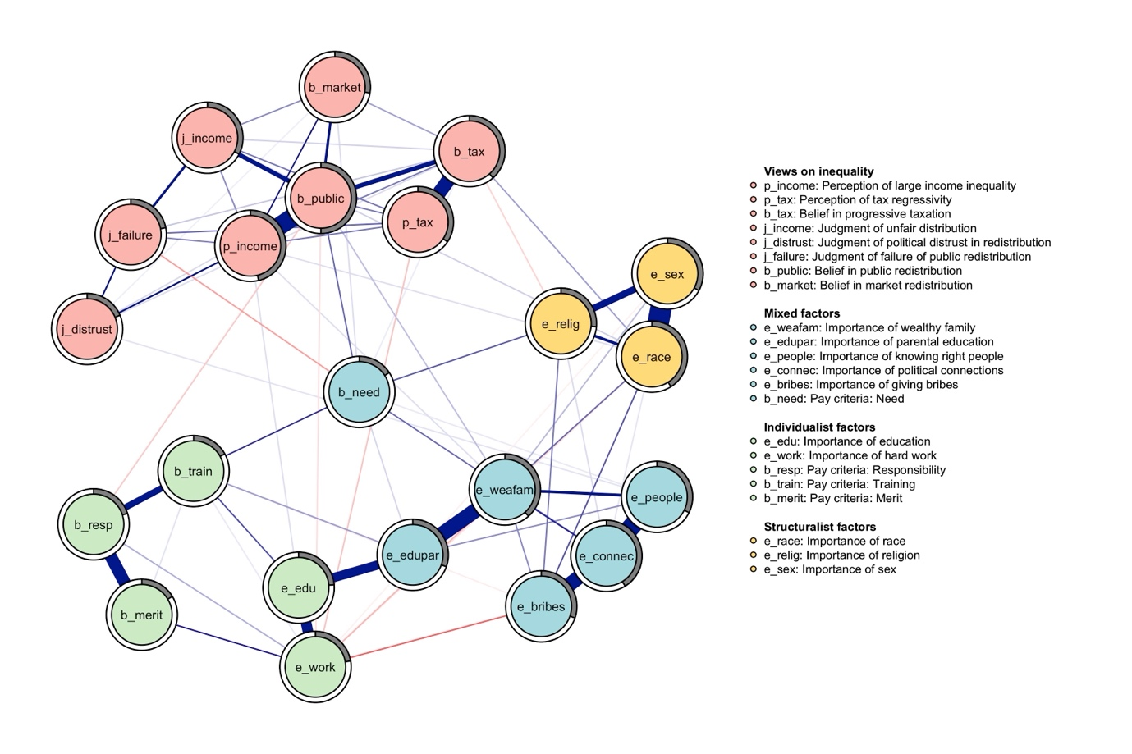

*Caption:* Mixed Graphical Model. Variables are represented as nodes, which are connected by weighted and signed edges. Nodes are colored according to community detection results. The circular shape around each node plots the partition of its variance that is explained by the model. Ties are indicative of the unique variance shared between each item pair. Their width is proportional to the strength of the corresponding associations. Blue edges represent positive linear influences, red negative ones.

Figure 2: Node centrality

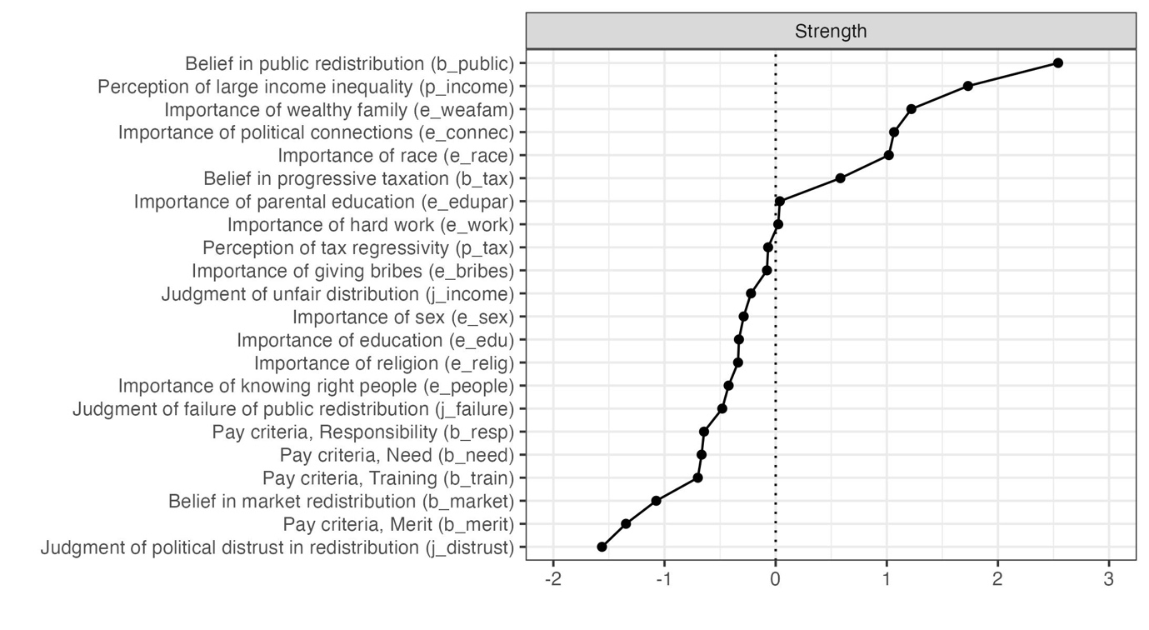

*Caption:* Strength centrality of mgm’s nodes. Each row shows one node and its centrality, measured in z-scores.

Figure 3: Inequality belief system at varying levels of anger towards inequality

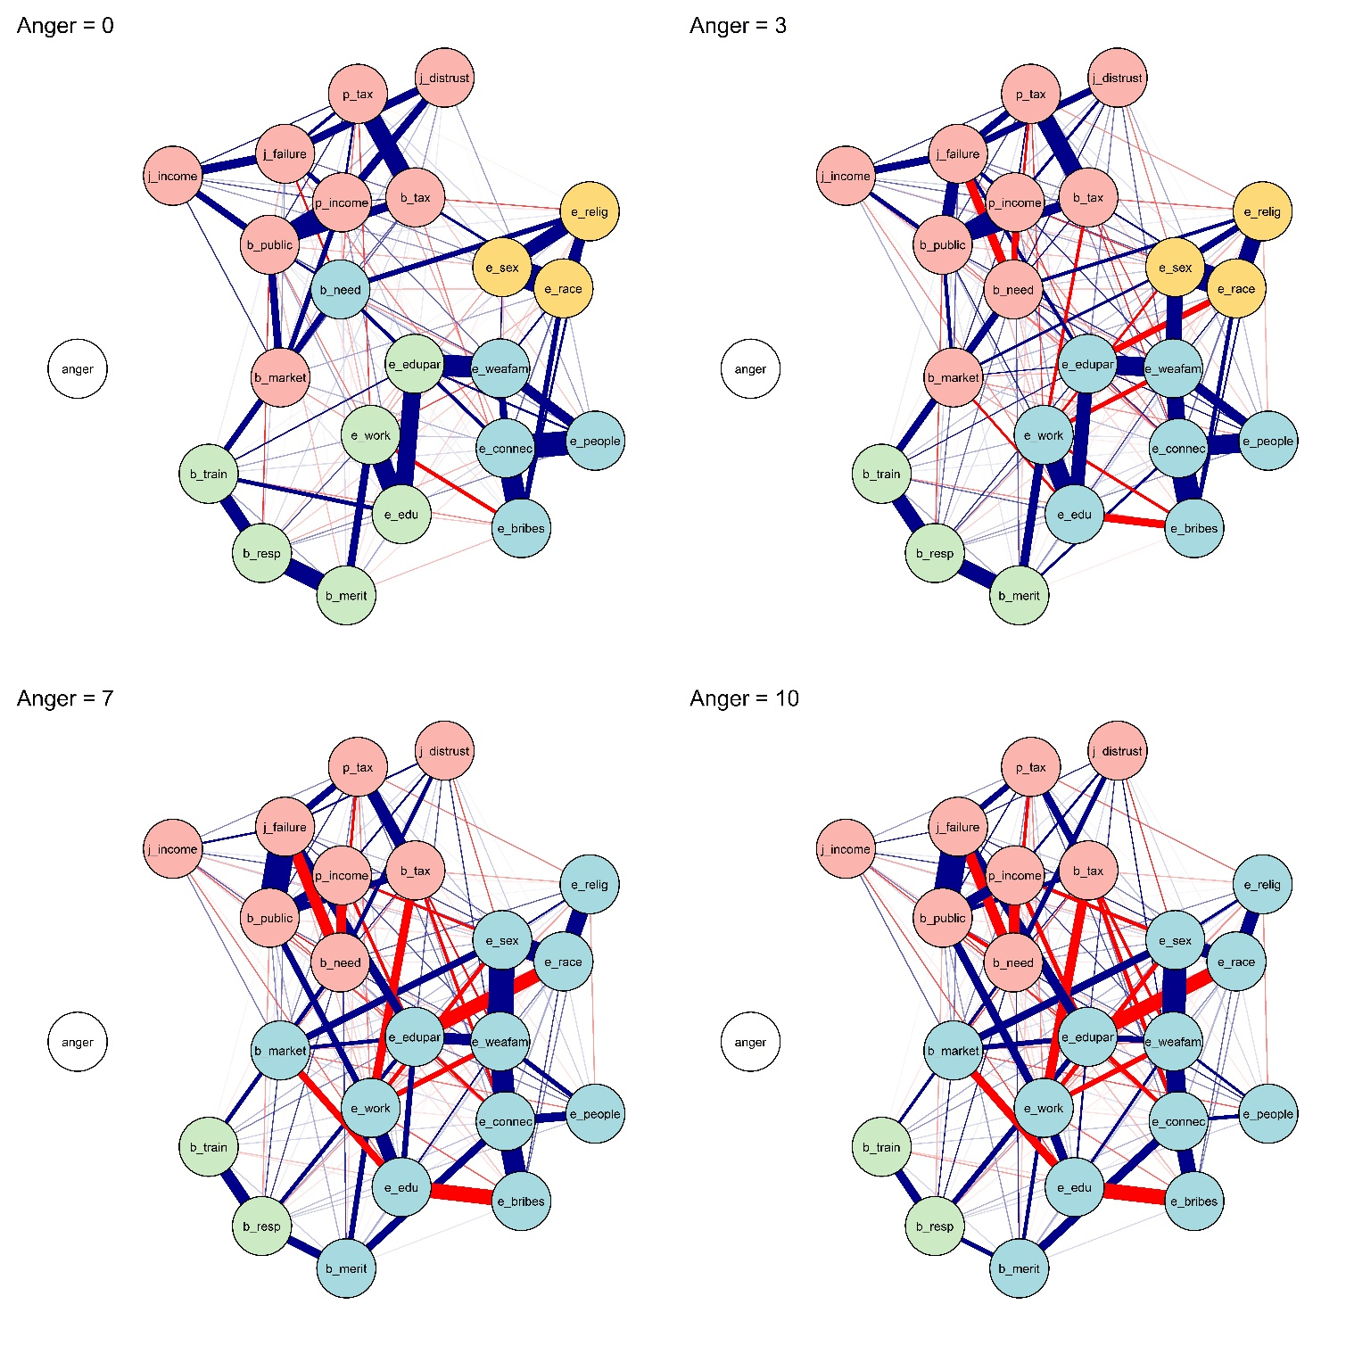

*Caption:* Each panel shows the result of a mgm estimation at a fixed level of the moderating variable, anger. Nodes are colored according to their classification in perceptions, beliefs, and judgments. Anger is plotted in white for clarity. Weighted and signed edges indicate conditional associations. Moderation effects are detectable by observing variations in edge color and/or width.

Figure 4: Inequality belief system and node centrality - Ising

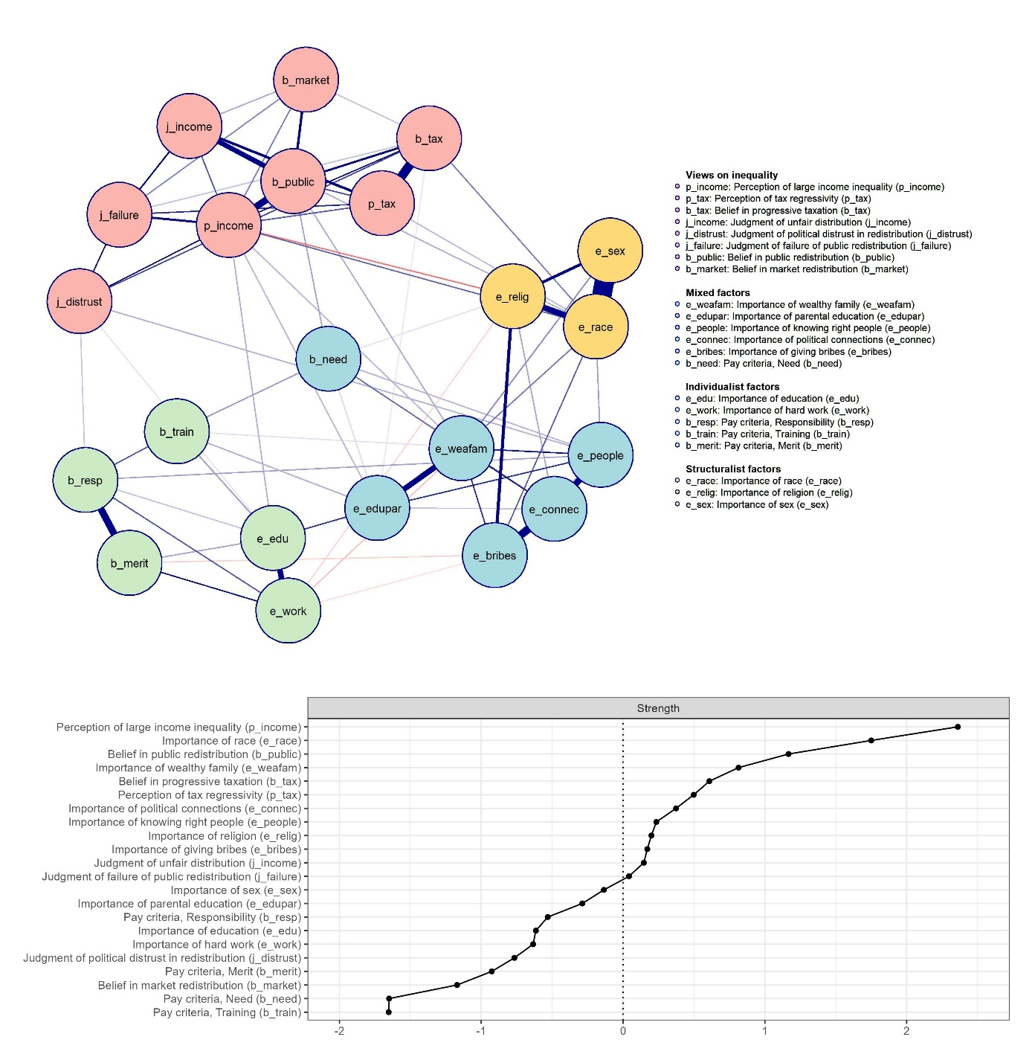

*Caption:* The top panel shows the results of the Ising estimation. The bottom panel shows z-scores of Strength centrality.

Figure 5: Network sum scores after simulated manipulation attempts

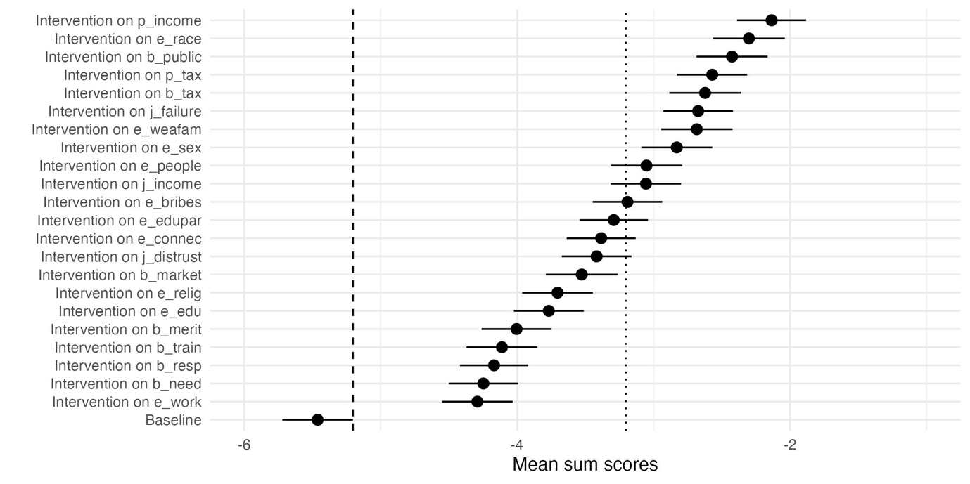

*Caption:* Each row is associated with a simulated manipulation attempt targeting one network node. Dots and confidence intervals show the mean sum score of the Ising network after each intervention. The dashed line on the left separates successful versus unsuccessful manipulations. The dotted line on the right represents the threshold for downstream effects.

1. In the remainder of the article, network nodes are indicated in italics.
2. Additional analyses reveal missing cases do not impact meaningfully on the final sample. Figure 6 of the Supplemental Material shows that variables present between 2% and 11% of missing cases. Thus, nonresponses were fairly distributed between the selected variables. Moreover, Table 3 of the Supplemental Material shows that the means of the variables do not differ significantly between the original sample and the reduced one
3. As a robustness check, H1 and H2 are also tested on the binary network (see Results section).
4. To cumulate with past research, the clustering coefficient and the ASPL are calculated from the absolute and unweighted adjacency matrix.
5. We avoid using additional centrality metrics due to concerns about their assumptions, which may not apply to belief networks. Bringmann et al. (2019) highlight that metrics like betweenness and closeness assume influence flows along the most efficient network paths. This assumption is problematic in belief systems, where nodes represent attitudes—constructs deprived of agency. Moreover, Dablander and Hinne (2019) showed that Strength centrality, unlike Betweenness and Closeness, strongly correlates with causal influence when combined with Directed Acyclic Graphs. Based on these findings, we use Strength centrality to evaluate H2 and H4, ensuring theoretical and methodological alignment with belief network analysis.
6. Variables were truncated considering their mean values. Descriptives are made available in Table 2 of the Supplemental Material. Additional analyses confirmed dichotomization of all nodes following different criteria (truncation at two, or three out of five points) does not impact the estimated network meaningfully.
7. For a throughout discussion on the performance of EGA, its similarity with factor analysis, and the adoption of the Walktrap algorithm for partial correlation networks, we refer interested readers to relevant validation studies (see Christensen et al., 2023, 2024; Christensen & Golino, 2021).
8. That is, the sum of the values of the state of all nodes (either -1 or +1). Hence, the sum scores range between -22 (all evaluative reactions are not endorsed) and +22 (every item is endorsed).
9. Parameters are selected to maintain comparability with the other studies adopting this simulation strategy (Dalege, Borsboom, Harreveld, & Maas, 2017; Schlicht-Schmälzle et al., 2018).